Basketball
On Tuesday Room9 had basketball training at Pokeno School with Coach Caleb. We went to basketball so we can be good at it and so we know what to do.
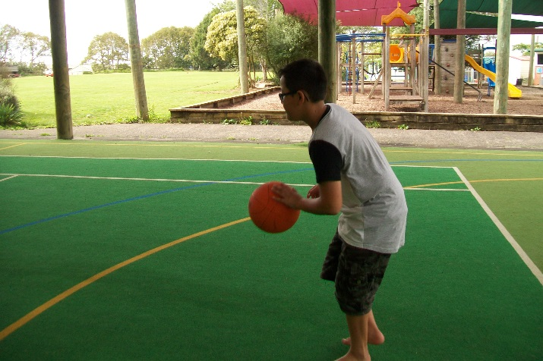
There are different kinds of lines in basketball, some lines are different to others, like the halfway line. The halfway line is in the centre of the basketball court. It is when they throw the ball in for the starting of the game. The base line is at the two ends of the court. The three pointer line is at the back of the two pointer line.
When you’re dribbling you need to remember to bounce the ball up to your waste or bellybutton. Your eyes are looking forward, not up, not down, but forward. Fingertips are all ways on the ball not your palm.
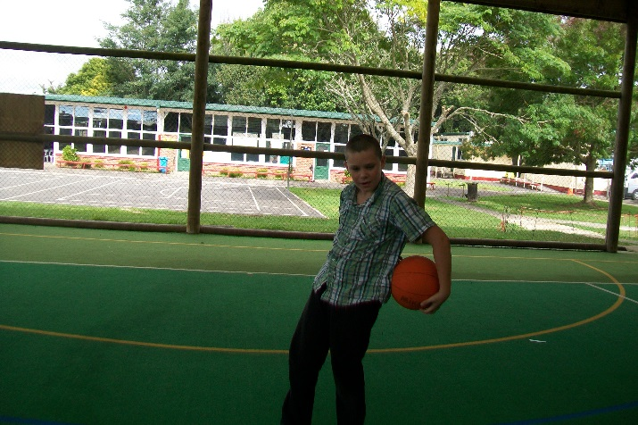
If you are doing a candy cane you need to hold the ball, guide it around your head, then waste and then around your feet. Then do it again but going upwards so you go around the waste and around your head again in that order.
When you pass the ball you pass from your chest. When you’re passing you step forward and make a W with your hands. When you pass the ball you need to look at your team mate.
When you do a figure 8 the ball has to go around your legs. The ball has to go between your legs like an 8. You can roll the ball or you can bounce the ball or just hold it in the air in your hands guiding it around your legs.
At the end of our basketball session we are exhausted. Room 9 really enjoys our basketball with Coach Caleb because he taught us lots of new awesome skills.
By Braydon, LD, Shannon, Tristan, Zeeshan
